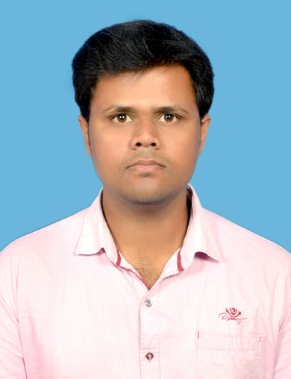
PRABHU R
Email : prabhukr4@yahoo.com
Phone : +91 9865998789
Address : No13/6A2, Thottasalai,
Karichipalayam, Vagrayampalayam (P.O),
Coimbatore- 641659, Tamilnadu, India.

PROFICIENCY

• An Engineering graduate with 3yearsofexperience in design, development, testing and implementation of Embedded system products across various domains.
• Having a strong passion to learn new technologies and have applied my skills to develop
innovative ideas into real world products to solve real world problems.
• Wish to say that if your product has performance constraints, limited memory resources, or
tight timing, I'm the person you would want to team up with.

TECHNICAL SKILLS
Microcontroller | - PIC 16F Series, dsPIC33f Series  - ATMEL and ATXMEGA128 Series  - 32-bit ARM7 (LPC214x)  - Arduino Series
Software Platforms | - MPLABX, MPLAB v8.30  - Atmel Studio 6.0  - Keil MDK ARM v4  - Arduino IDE  - PROTEUS 7.7(Simulations)
Debugging Tools | - PICkit 3 (Microchip)  - AVR Dragon(ATMEL)  - LPC Xpresso Debugger (NxP)  - Topwin6  - Digital Signal Oscilloscope (DSO)
Programming Language | - Embedded C
Internal Peripherals | - RS485 with MODBUS  - I2C / SPI / UART  - ADC / DAC  - TIMER / PWM  - GPIO  - Interrupts
External Peripherals | - Alphanumeric LCD  - Analog and Digital Sensors  - Motor Driver  - EEPROM  - GPS / GSM / RFID / Zigbee Transceiver /Bluetooth  - Resistive Touch screen

1 | P a g e
EXPERIENCE

- LAKSHMI MACHINES WORKS (MTD)
Duration - February 2011 to 2012
Function - Diploma Trainee in CNC Machine assembling (R&D)
Location - Coimbatore
- SIRIUS TECHNO SOLUTION
Duration - May 2015 to Feb 2017
Function - Embedded Developer
Location - Coimbatore
- MAK CONTROLS AND SYSTEMS PVT. LTD
Duration – Feb 2017 to Till
Function - Embedded Engineer
Location - Coimbatore
Responsibilities:
• Design and Develop firmware for embedded system peripherals
• Analyze and enhance efficiency, stability and scalability of system resources
• Interface with hardware design and development
• Analysis and validation of a product design
• Documentation for the project and product design

PROJECT DETAILS
Project 1:
Description
Name | SMART I/O MODULE
Role | Software Developer
Team Size | 3 Persons
Responsibilities | - Develop the code for the Microcontroller (dsPIC33fj64gs606) used in the System.  - Testing and analysis of real-time working and performance of the Project.
Description | - The main objective of the project is to expand the input/output functionality of CPU and this Module act as a slave for the main system. Module will configure by RS232 Port and data sharing by RS485 communication with MODBUS Protocol.
Language | Embedded C
Development Tools | MPLABX, xc16 compiler
Microcontroller and  Modules | dsPIC33FJ64GS606-16bit Controller

2 | P a g e
Project 2:
Description
Name | MACHINE TO MACHINE COMMUNICATION MODULE (M2M)
Role | Software Developer
Team Size | 3 Persons
Responsibilities | - Develop the code for the Microcontroller (ATxmega128a4u) used in the System.  - Testing and analysis of real-time working and performance of the Project.
Description | - Main objective of M2M wireless module is to arrive at a common Diagnosis solution for all machines. The System will act as a plug and play device for all the Machines, facility to collect all the required parameters for Monitoring purpose such as, Date, Time, Location, System Faults, and Product ID with certain period of time.
Language | Embedded C
Development Tools | Atmel Studio 6.0, AVR Dragon, Tera term
Microcontroller and  Modules | ATXMEGA128A4U, GPS, GSM/GPRS, RS458 with MODBUS Protocol

ACADEMIC QUALIFICATIONS
✓

Kathir College Of Engineering, Coimbatore
B.E., Electronics and Communication Engineering with CGPD: 6.90 (April 2015)

✓ Nanjappa Polytechnic College
Diploma in Electronics and Communication Engineering with 80% (April 2010)

✓ Government Higher Secondary School, Vagarayampalayam, Coimbatore
SSLC with 72.00% (April 2007)

PERSONAL INFORMATION
Father’s Name : K.A.Ramasamy
Mother’s Name : R.Kalamani
Date of Birth : 06-07-1992
Nationality : Indian
Languages known : Tamil and English

DECLARATION
I hereby declare that the information furnished above is true to the best of my knowledge.

Place : Coimbatore Yours Sincerely,
Date :
R.Prabhu
3 | P a g e

